PFC - Assignment – part 3
Income tax bill and summary report with Files

As your third assignment in this semester, you are to amend your program to store and manage personal tax data on file.
Learning Outcome
Upon successful completion of this assignment, you will have demonstrated the ability to use sequential files (text or binary file).
Specifications
On completion, your program displays the menu as belows:
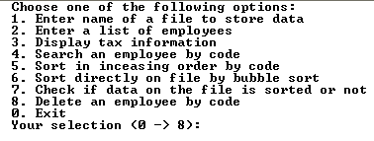
You can select the option 1. to load data from the file tax.dat. After that you select the option 3 to display data. The output will like the following:
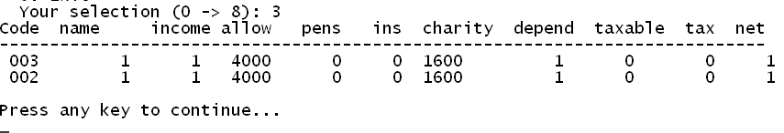
You can run the tax3.exe file to know how the program should work.

Submission Requirements
At the beginning of your program, include comments reflecting accurate information for you in the format as below:

/*
Assignment 1 - Income tax
Class ID : SE0424
Student ID : 00400
Student Name : Nguyễn Minh Đức
Due Date : 12 February 2009
I declare that this assignment is my own work
in accordance with FPT Policy.
*/

